AMAZON REVIEW INSTRUCTIONS

- Log-in to your amazon account
- Search for Maggie Casteen or title of book (Killer Deception, Hush Now, Don’t Cry)
- Scroll down until you see ‘Customer Reviews’ and click on blue text
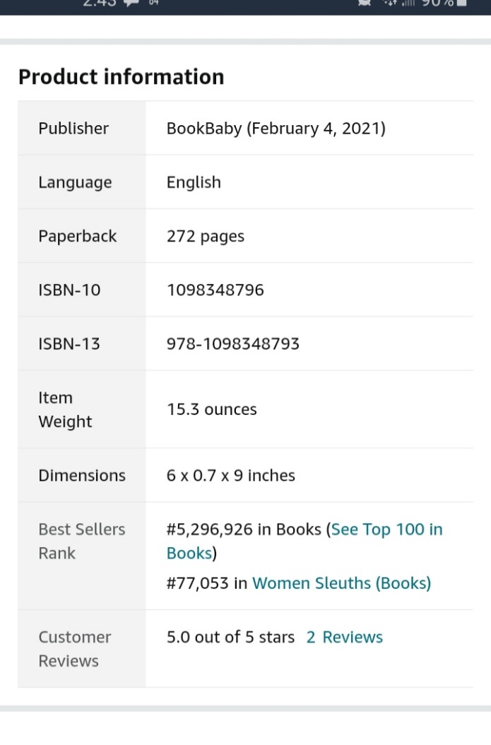

- Click on ‘Write a Review’ in the top corner of page
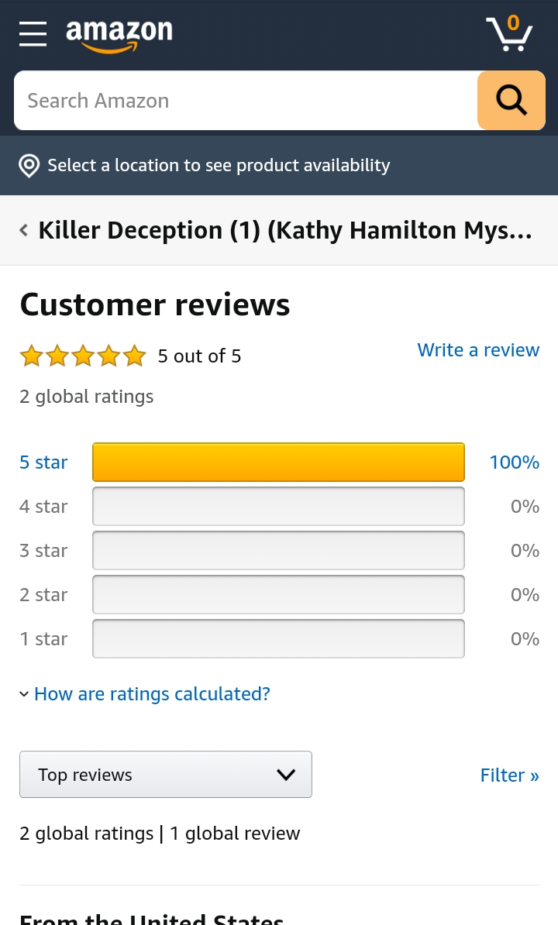
- Then write your review – It will be posted pretty quickly.

Thank you in advance for leaving a review!
I really appreciate it!

